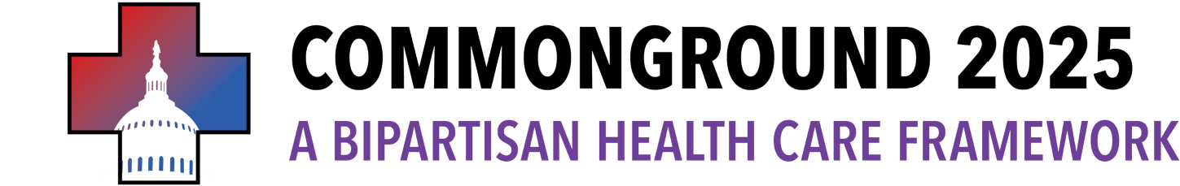
Top-line Summary.
Two-year extension of health insurance premium savings for American families — including a year of the enhanced Premium Tax Credits (ePTCs), with targeted modifications, to be voted on by December 18, 2025, in the U.S. Senate and House of Representatives.

Year One: An extension of the ePTCs, with targeted modifications.

- Extension of the ePTCs for enrollees earning less than 600% of the federal poverty level (FPL) and a phase out of the ePTCs for enrollees earning between 600% FPL and 1000% FPL.
- New guardrails to prevent “ghost beneficiaries” and crack down on fraud, including:
  - Implementing the Insurance Fraud Accountability Act to crack down on civil & criminal penalties for fraudulent agents / brokers;
  - Codifying part of CMS’s marketplace integrity rule to remove bad actors from ACA marketplaces;
  - Directing ACA marketplaces to regularly confirm enrollee eligibility with the Death Master File; and,
  - Requiring marketplaces to better notify recipients of the amount of PTCs they are receiving from the federal government.

- Extension of open enrollment until March 19, 2026, and requiring HHS to notify qualified individuals of the extension of open enrollment.
- PBM reform (provisions included in the bipartisan Continuing Resolution from December 2024 and featured in the PBM Reform Act and Bipartisan Health Care Act) which:
  - Bans “spread pricing” in Medicaid.
  - Reforms Medicare Part D by delinking PBM compensation from the cost of medications.
  - Promotes transparency for both employers and patients in their prescription drug plans.

Year Two: Continued health insurance premium savings, including more significant reforms, agreed upon and voted on in the U.S. Senate and House of Representatives by July 1, 2026.

Reforms for consideration:
- Option for consideration: Medicare physician fee schedule (from December 2024 CR).
  - Boosts the Medicare Physician Fee Schedule.
- Option for consideration: Hospital billing transparency.
  - Requires hospitals to disclose prices, including negotiated rates and cash prices.
- Option for consideration: Give Kids A Chance Act (from December 2024 CR).
  - Accelerates pediatric cancer treatments and expands access to life-saving therapies for children battling rare diseases.
- Option for consideration: Elimination of zero-dollar premiums with minimum monthly payments, but with need-based hardship support for those who cannot afford this payment.
- Option for consideration: HSA Accounts (Sen. Cassidy proposal).
  - Shifts funding that would have paid for the ePTCs to HSA accounts.

Potential Pay-fors.
- Anti-Fraud provisions of IFAA, HOPE Act: not yet scored, but substantial.
- PBM reforms: as delineated in the December 2024 CR.

